Cookies and Clouds

Baldassarre Mario & Adrian Schachter

June 2nd to June 13th, 2021

Limmatstrasse 270, 8005 Zurich

Press Release, May 2021
Cookies and Clouds
Works by Baldassarre Mario and Adrian Schachter theStable Limmatstrasse 270, 8005 Zurich
theStable is pleased to announce a two-person pop-up exhibition ‘Cookies and Clouds’ with Baldassarre Mario (born 1993 in London, lives and works in Florence) and Adrian Schachter (born 1996 in New York, lives and works in the Engadine). The exhibition features new works by the two artists made in harmony over the past months at their studios in the Engadin and in Florence.
The works focus on subjects and themes the two artists accumulated over years while studying and working in Berlin and New York. Looking through the lens of cultural anthropology, personal emotions, and lived experiences, they scavenge the internet with its visual soundbytes, scrambled contexts, and gaudy ambient colors. Adrian and Baldassarre carried out extensive research to shine light on the absurdities of everyday life. Things we take for granted become invisible to the naked eye, often times neglected without being appreciated. The works follow their exploration and analysis of rummaging through the digital realm, researching and finding topics they assimilate with a hint of irony and humor, yet ultimately convey a more serious and melancholic undertone.
Having the chance to wind-down in the past year and take a more reflective approach to their work enabled the artists to employ new techniques that lead them down a path of highly developed and intricate paintings. Adrian Schachter makes use of acrylic and tempera to paint on canvas and board filling out the surfaces with a variety of found motifs. Like a foreign body latched onto an organism the accumulation of found images retain engrossing details. Baldassarre Mario posits his more intimately scaled works on paper into bold new works on canvas that expand on his abstract language of lively interlaced color combinations.
Both of these young artists extrapolate the flotsam and jetsam of the information age with its cult of influencers, mash-ups, satire, visual puns, and banalities. Truth lies in their side-view of things not taken at face value, rather they take on the chimeras and noise of a nebulous alter-world.
‘Cookies and Clouds’ will run from the 2nd of June until the 13th of June at the Lowenbrau Areal in the heart of Zurich. The show will be open daily from 10:00am until 07:00pm and by appointment. For questions please Mail: fritz@thestable.world

EXHIBITION VIEWS

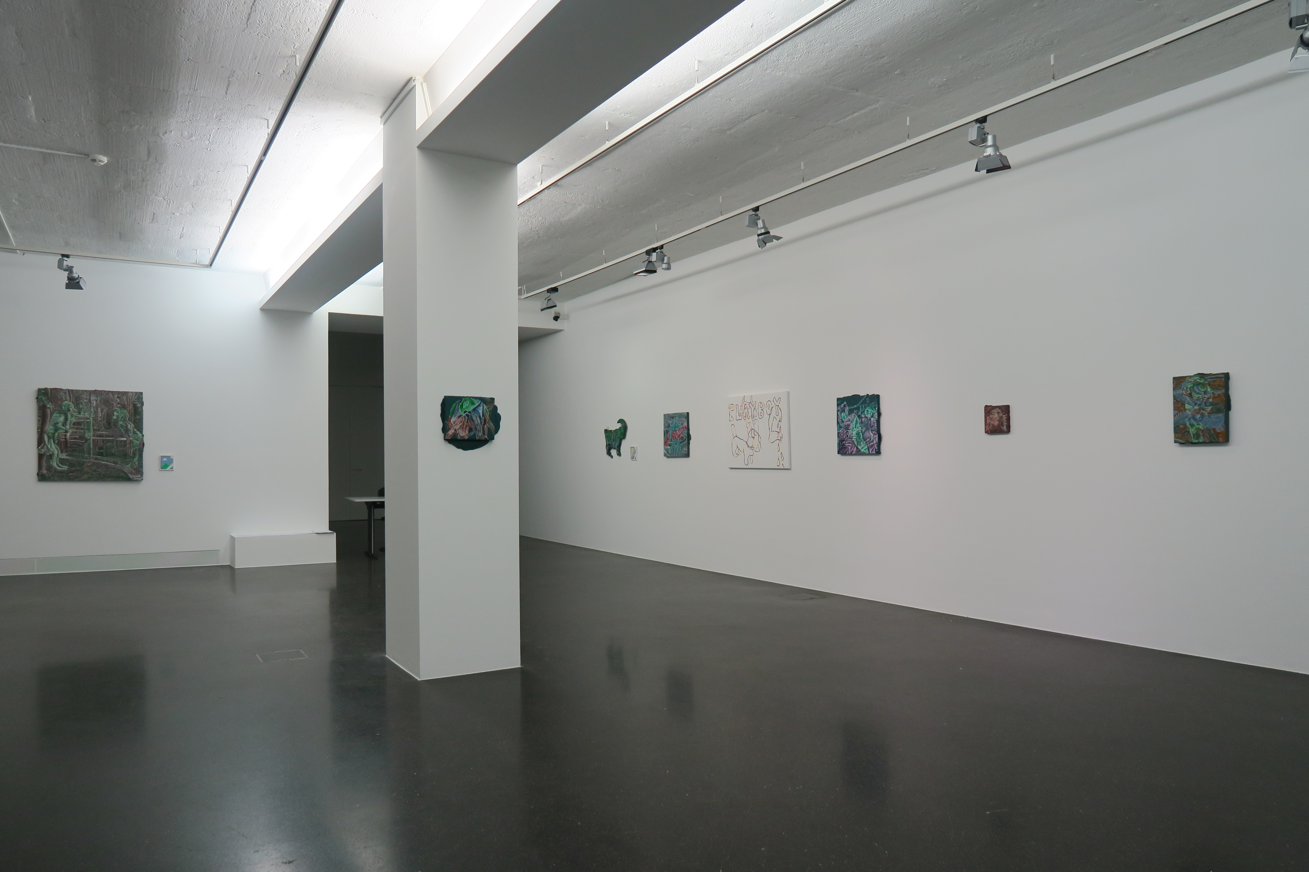

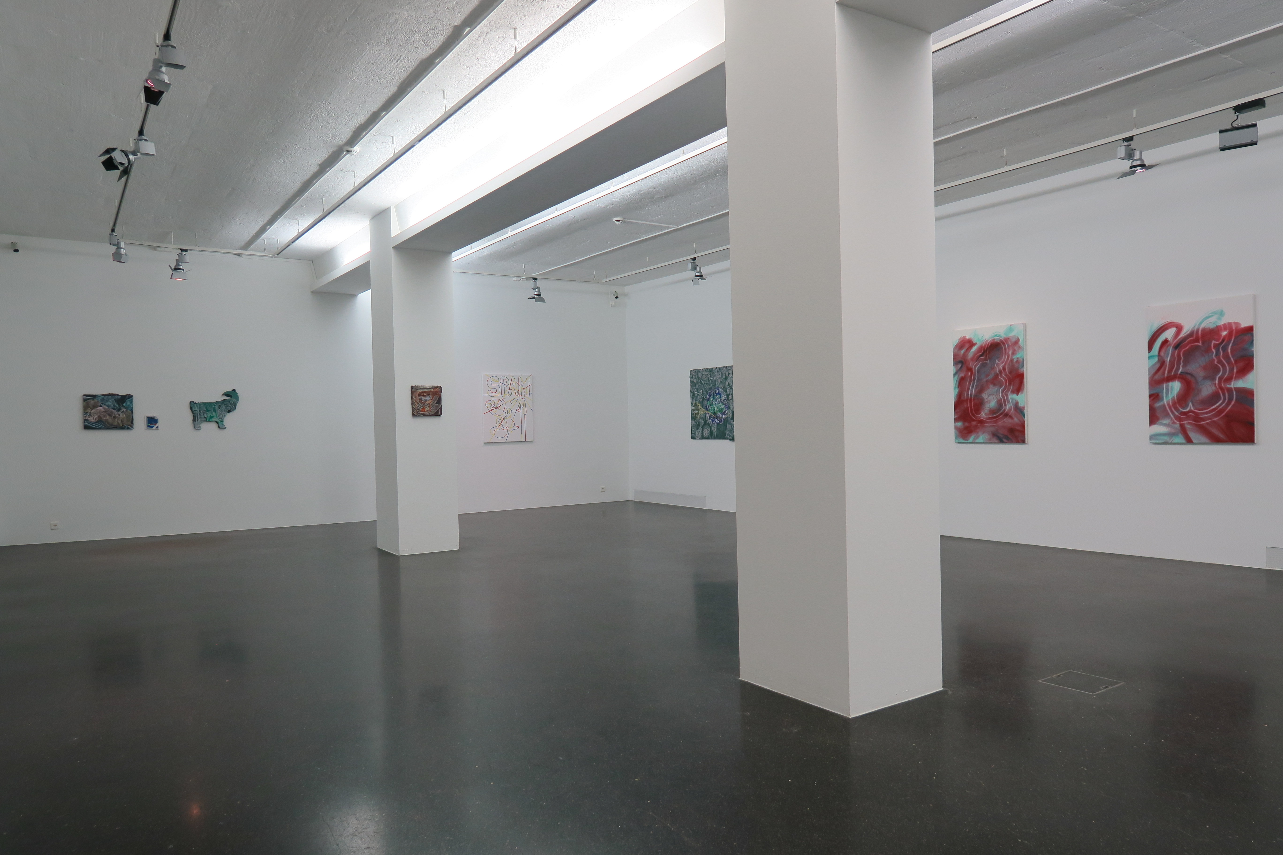

Exhibition view, Cookies and Clouds, theStable, Zurich, 2021

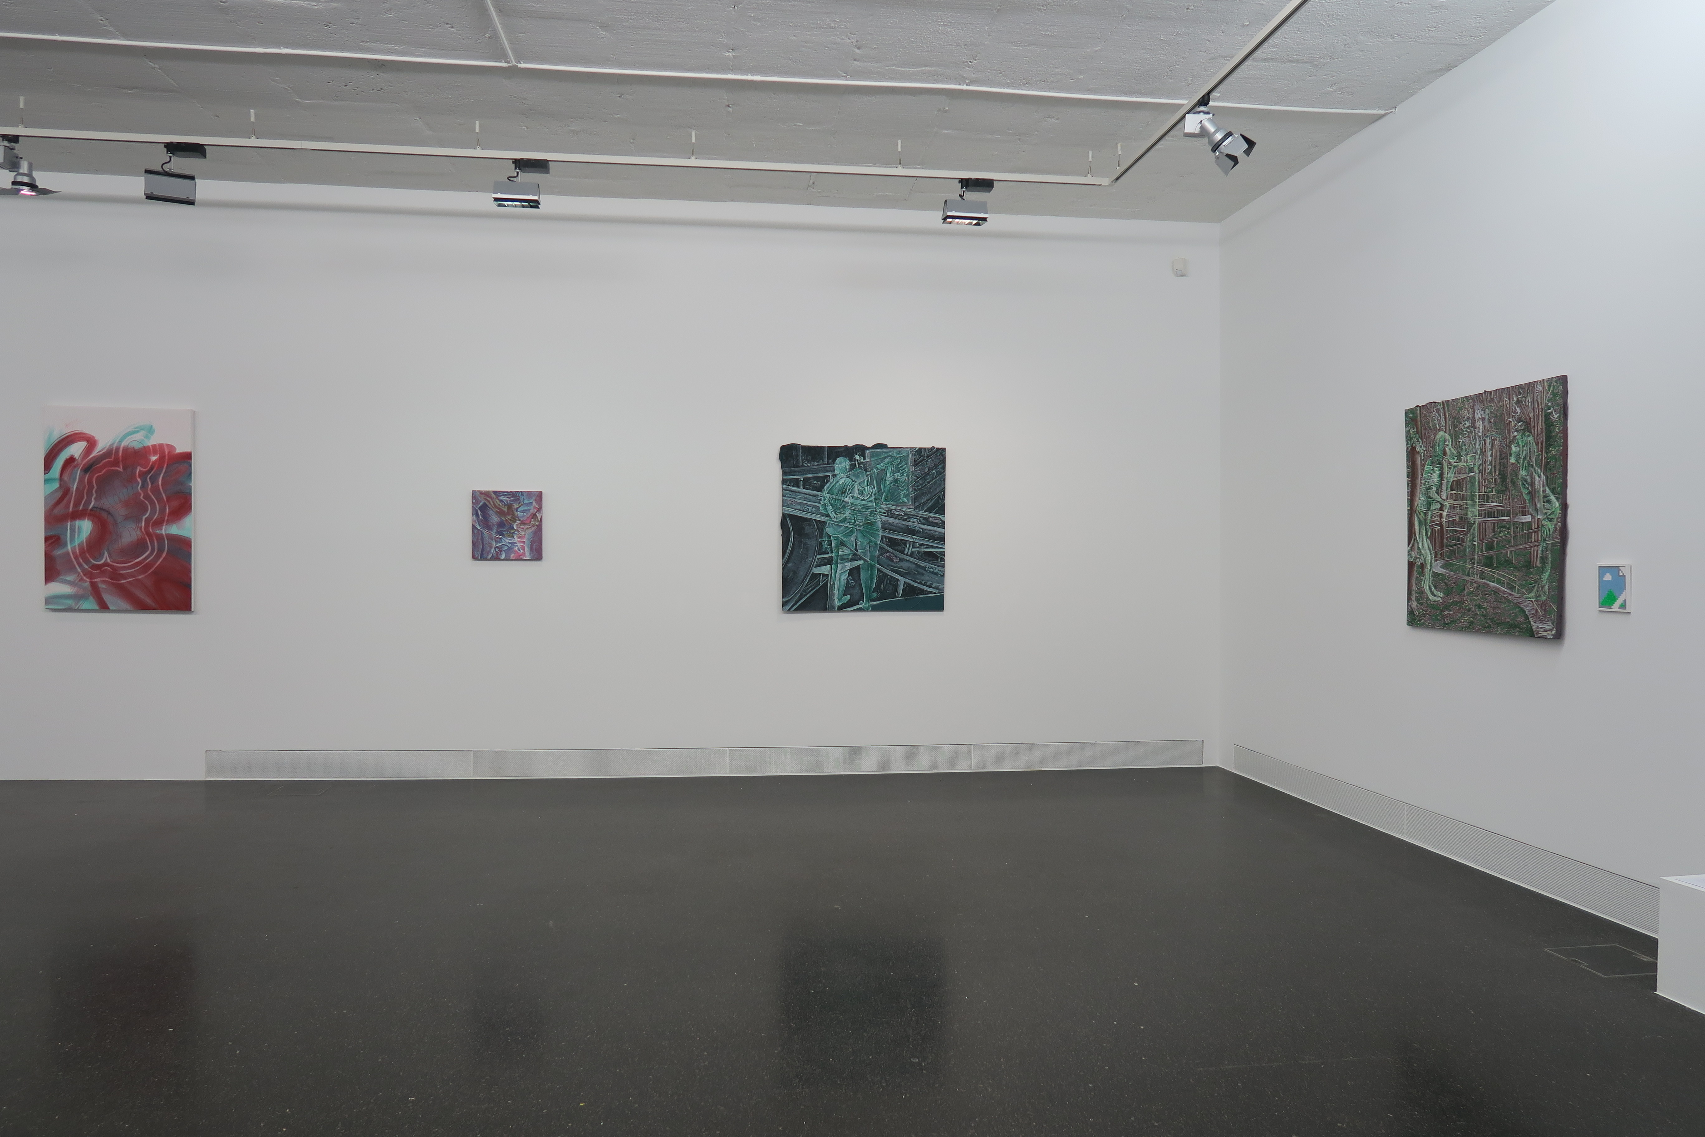

Exhibition view, Cookies and Clouds, theStable, Zurich, 2021

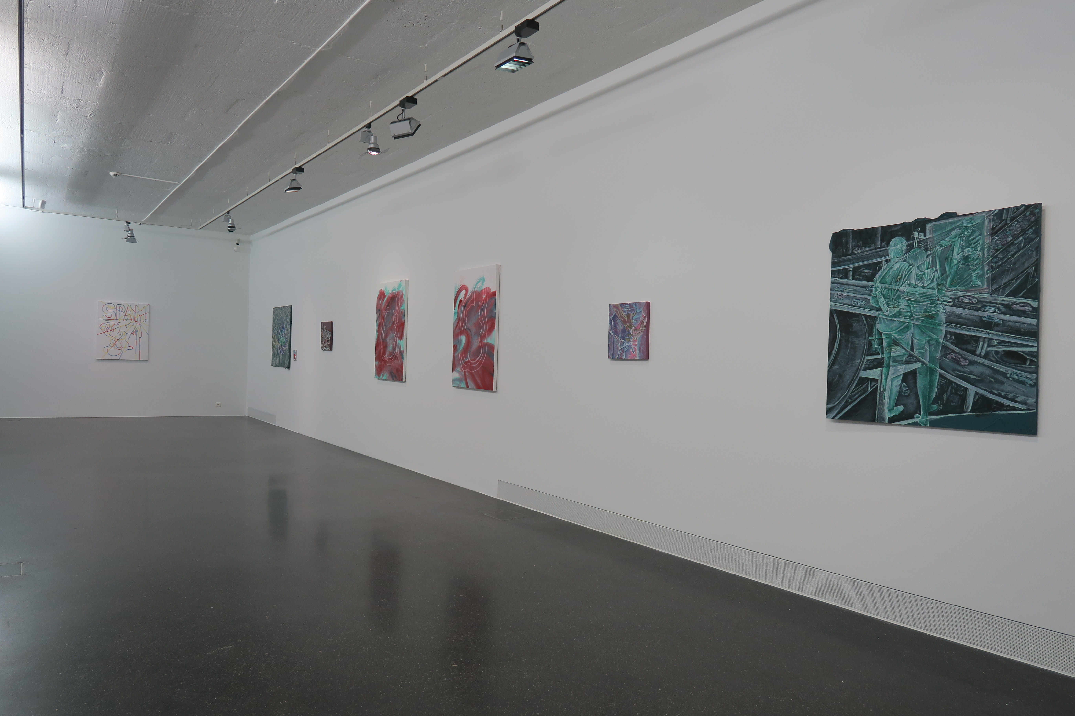

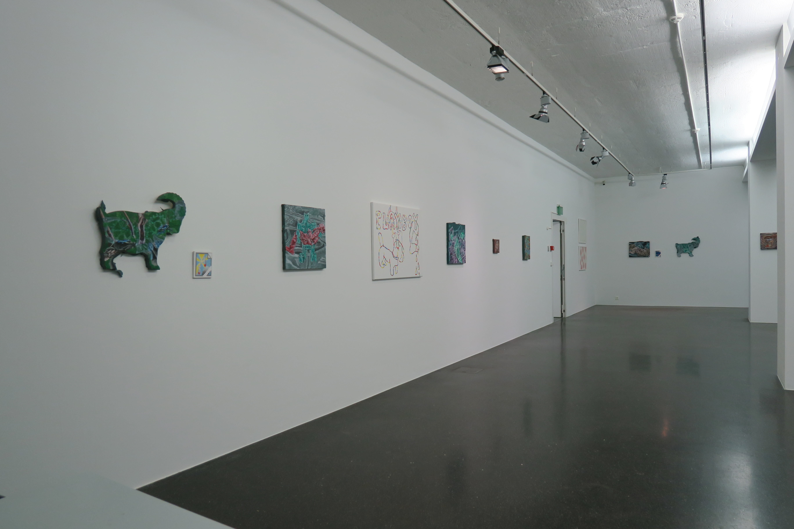
Exhibition view, Cookies and Clouds, theStable, Zurich, 2021

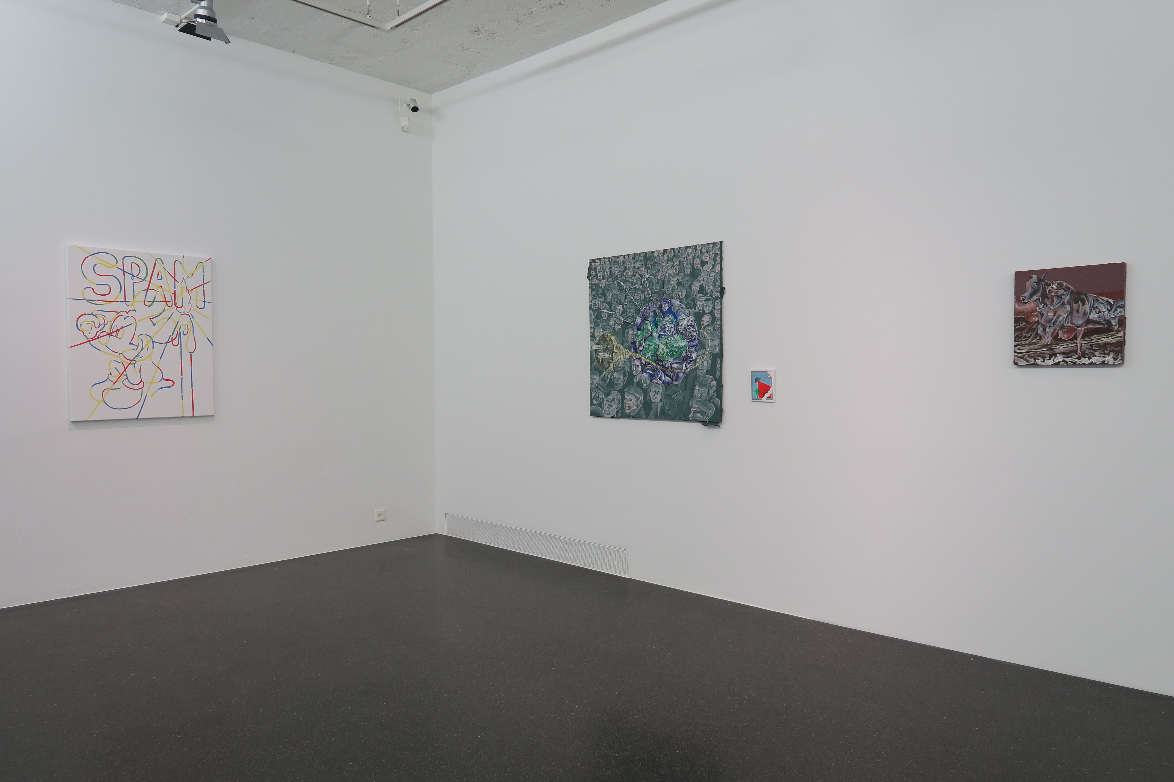

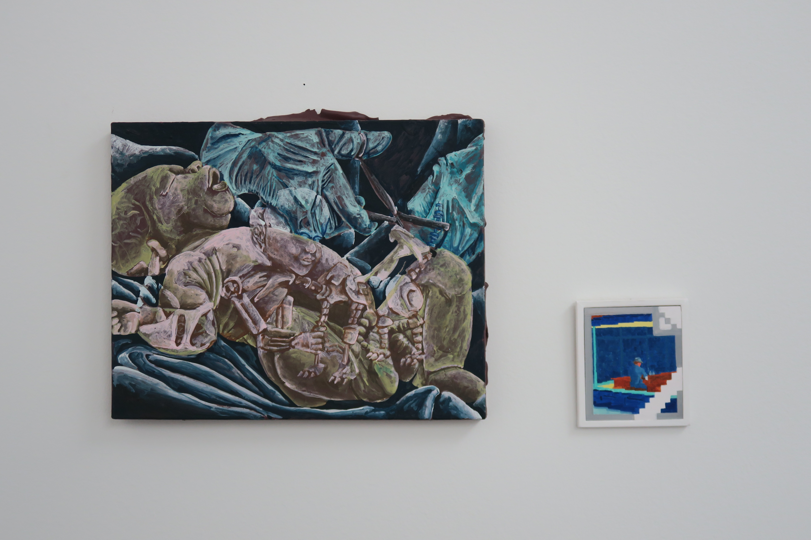

Exhibition view, Cookies and Clouds, theStable, Zurich, 2021

ADRIAN SCHACHTER

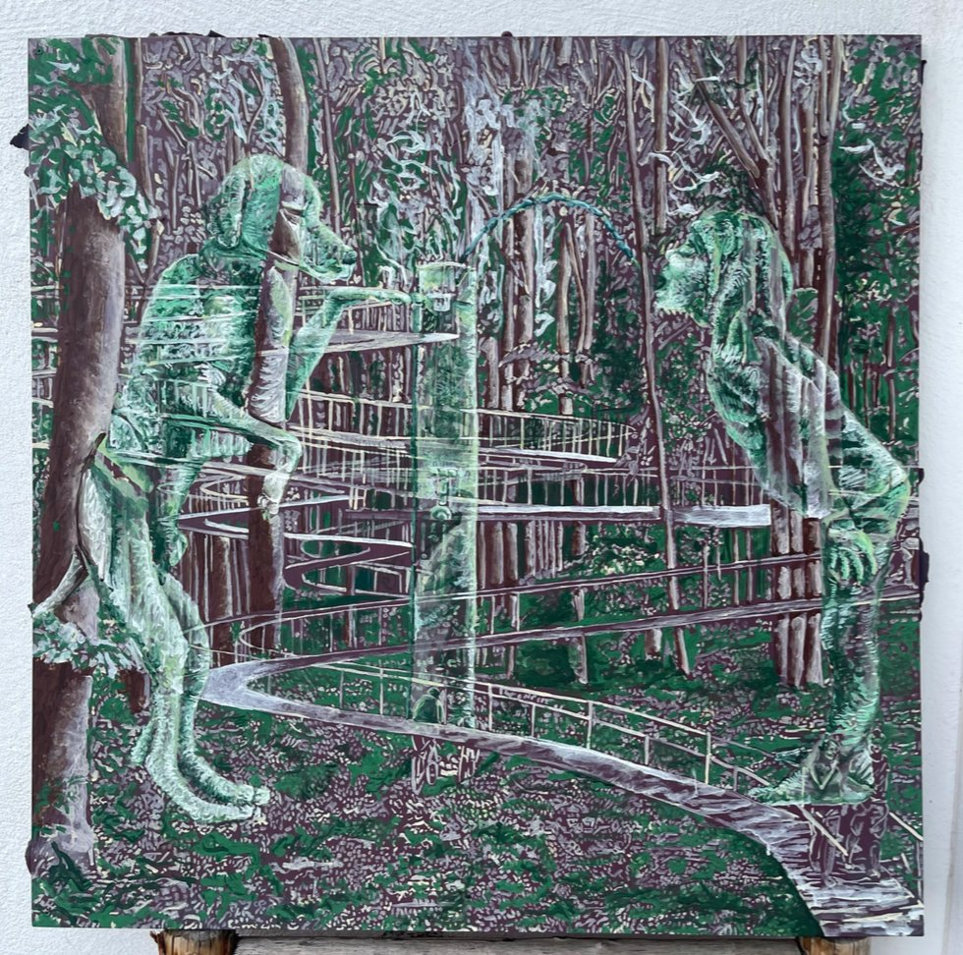

Adrian Schachter
Some kind of Nature, 2021
Tempera, acrylic and modeling paste on wooden panel
100 x 100

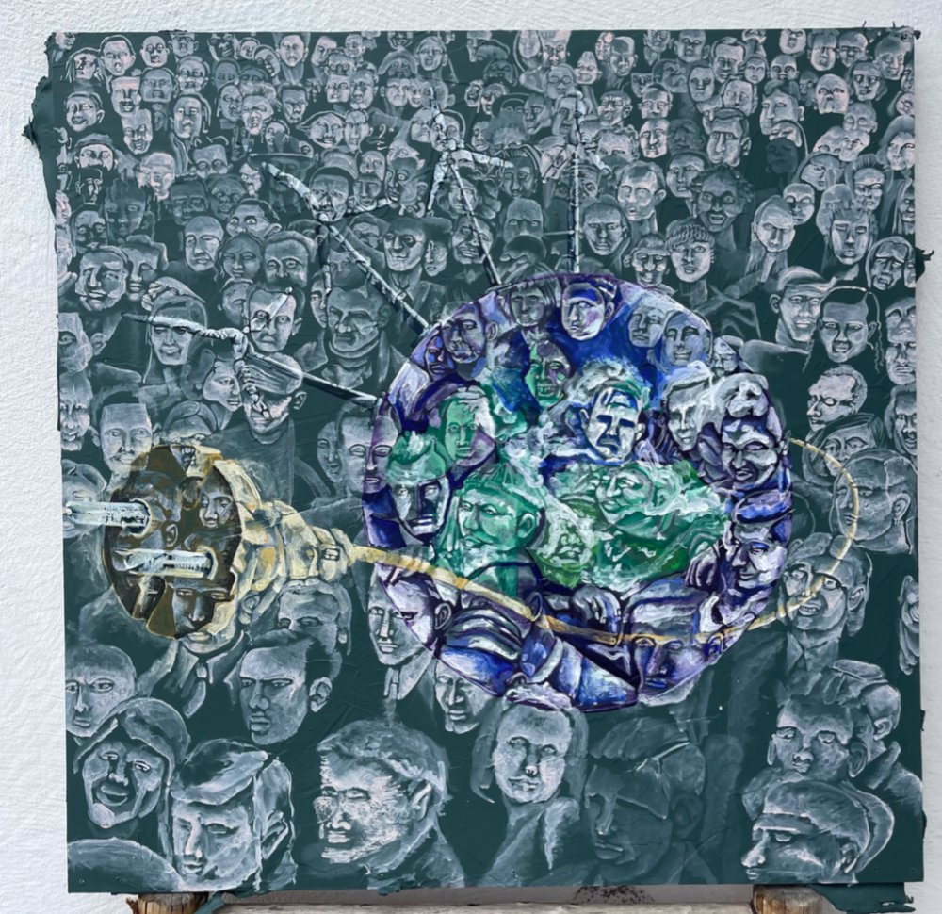

Adrian Schachter
Untitled (singularity), 2021
Tempera, acrylic and modeling paste on wooden panel
100 x 100

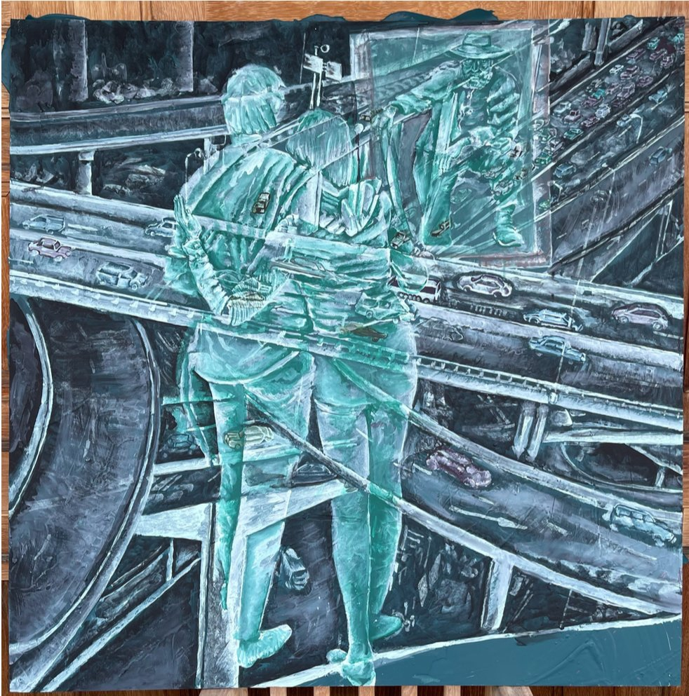

Adrian Schachter
People are awesome, II , 2021
Tempera, acrylic and modeling paste on wooden panel
100 x 100

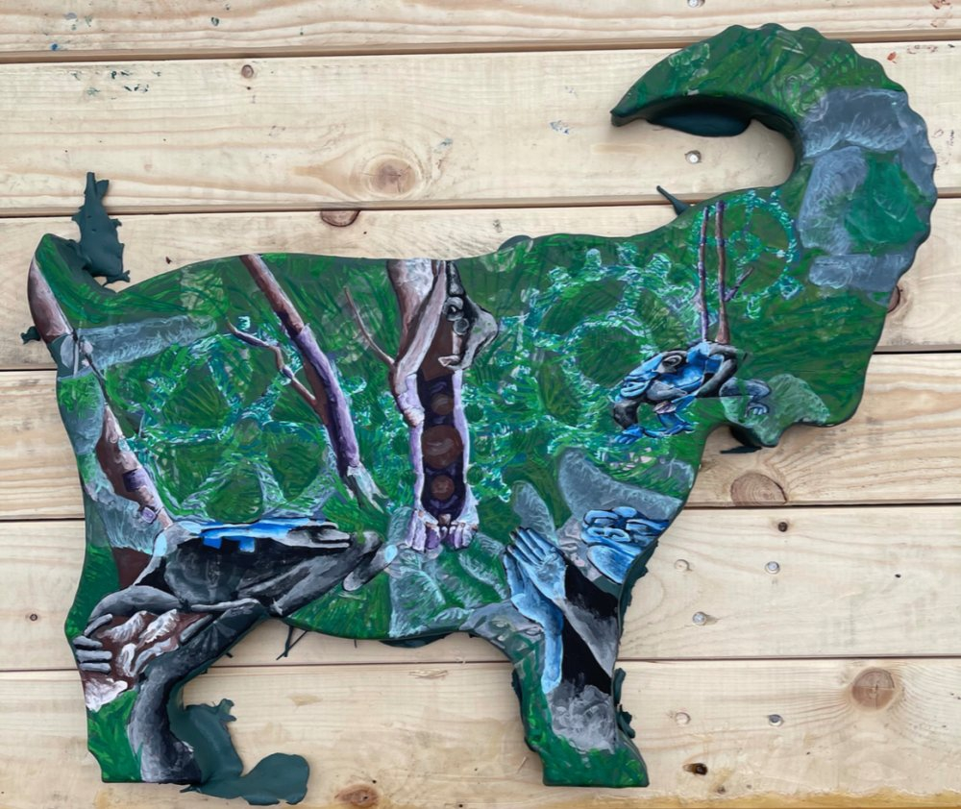

Adrian Schachter
Proto-religious and other overachieving behavior, 2021
Tempera, acrylic and modeling paste on shaped wooden panel
55 x 47.5

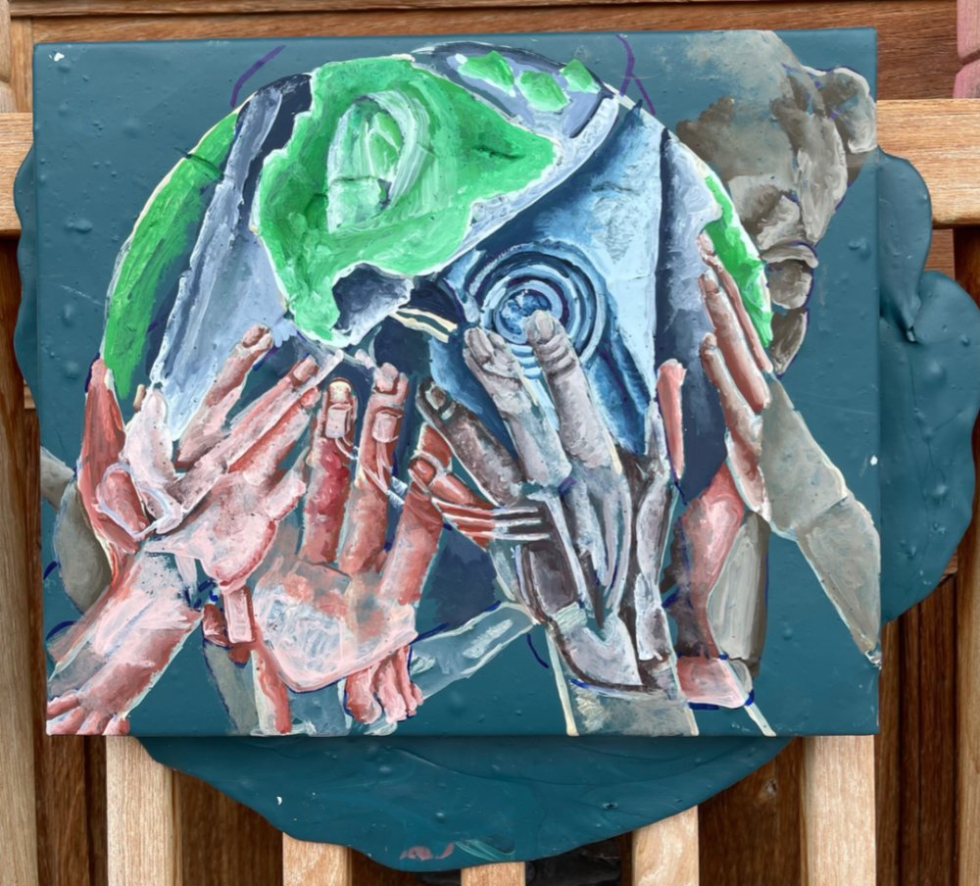

Adrian Schachter
Dog world, 2021
Tempera, acrylic and modeling paste on wooden panel
37 x 32

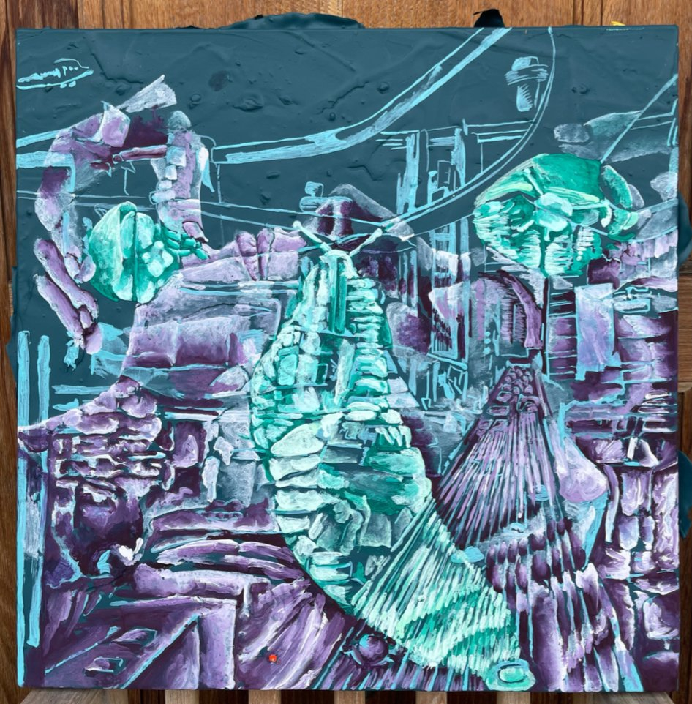

Adrian Schachter
Society if we all did snail therapy, 2021
Tempera, acrylic and modeling paste on canvas
50 x 50

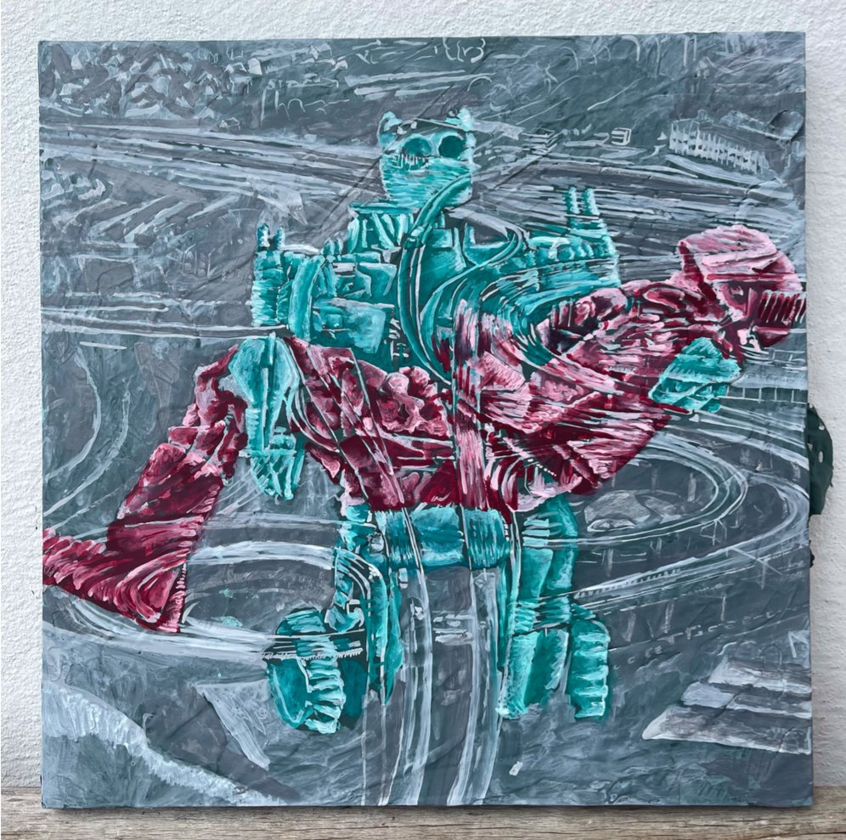

Adrian Schachter
Untitled, 2021
Tempera, acrylic and modeling paste on wooden panel
50 x 50

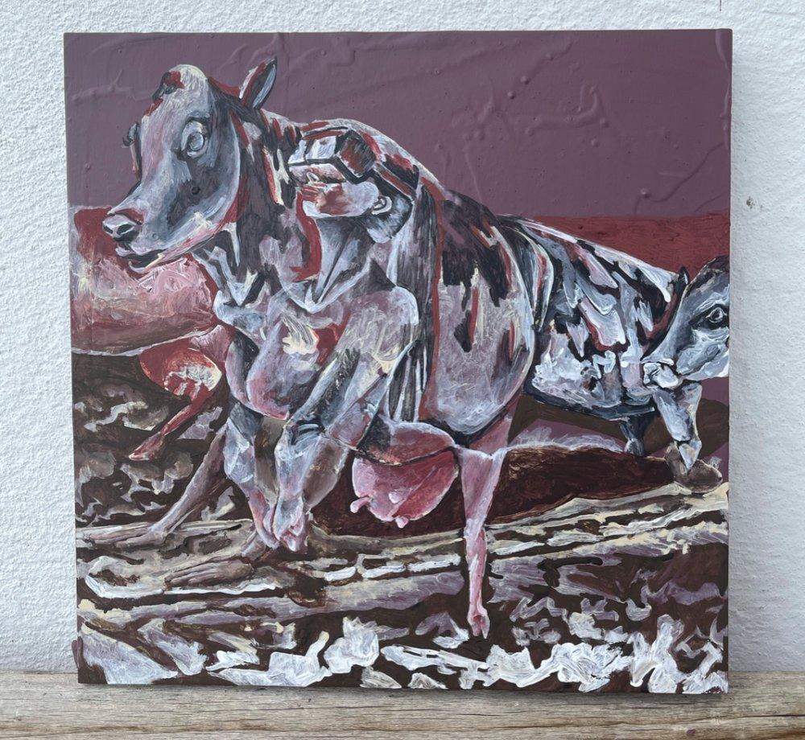

Adrian Schachter
Untitled (cows), 2021
Tempera, acrylic and modeling paste on wooden panel
40 x 40

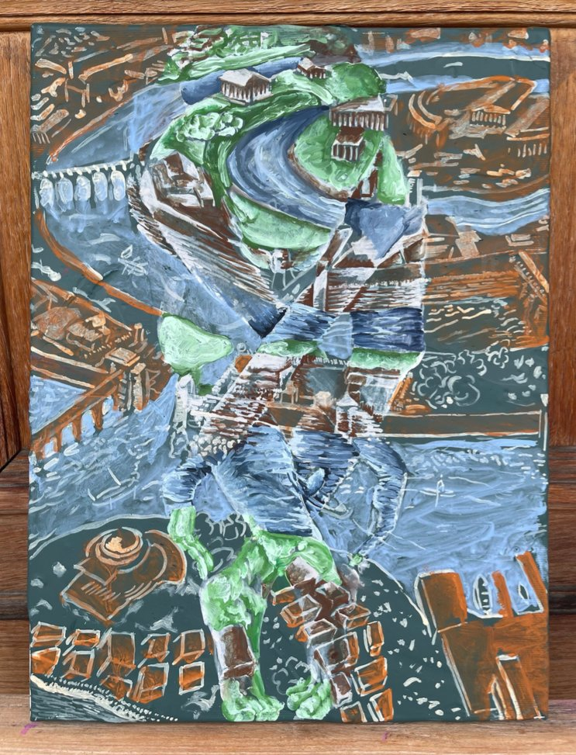

Adrian Schachter
Atlantis dancer, 2021
Tempera, acrylic and modeling paste on canvas
40 x 30

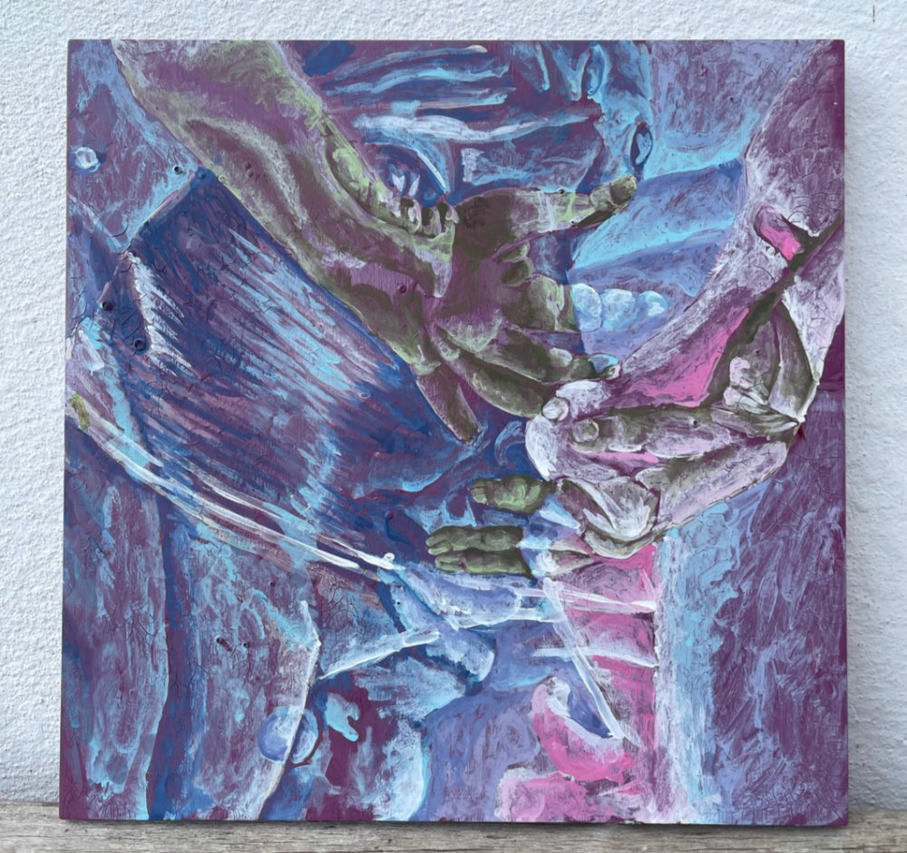

Adrian Schachter
Singularitarian couple, 2021
Tempera, acrylic and modeling paste on wooden panel
40 x 40

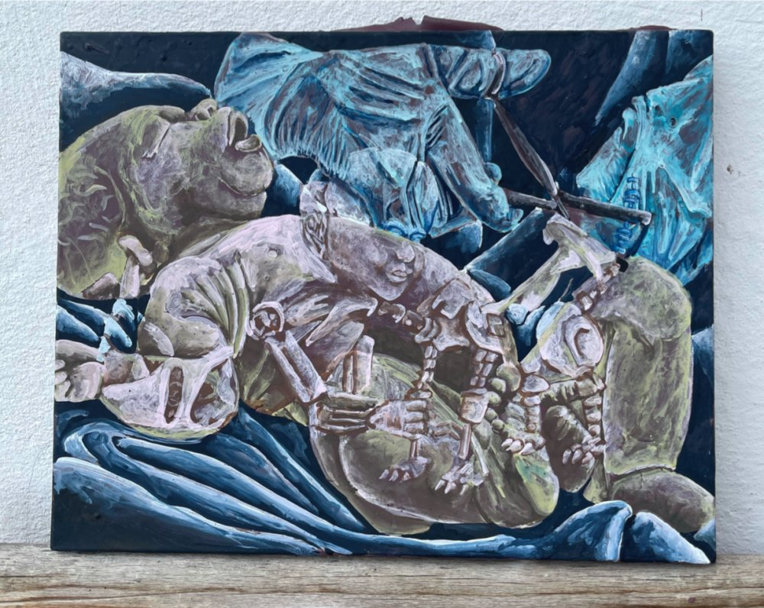

Adrian Schachter
Baby and bots, 2021
Tempera, acrylic and modeling paste on canvas
50 x 40

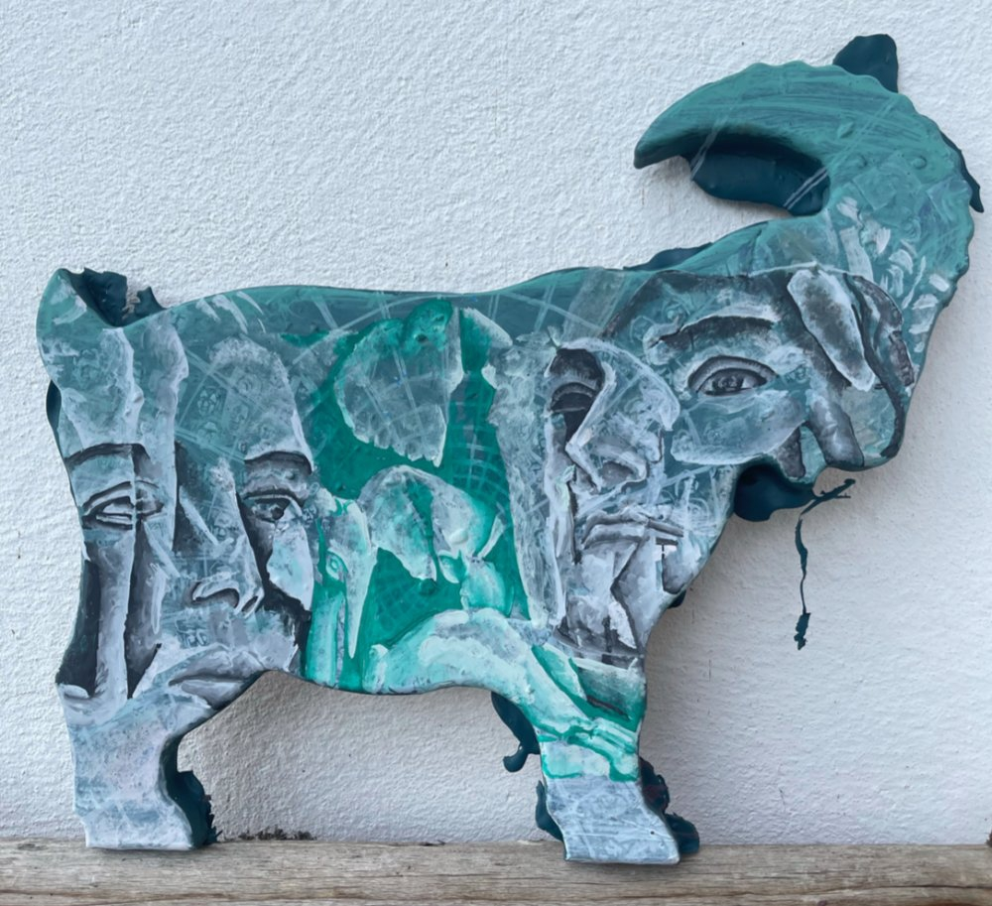

Adrian Schachter
Singularity/Elephant funeral, 2021
Tempera, acrylic and modeling paste on shaped wooden panel
55 x 47.5

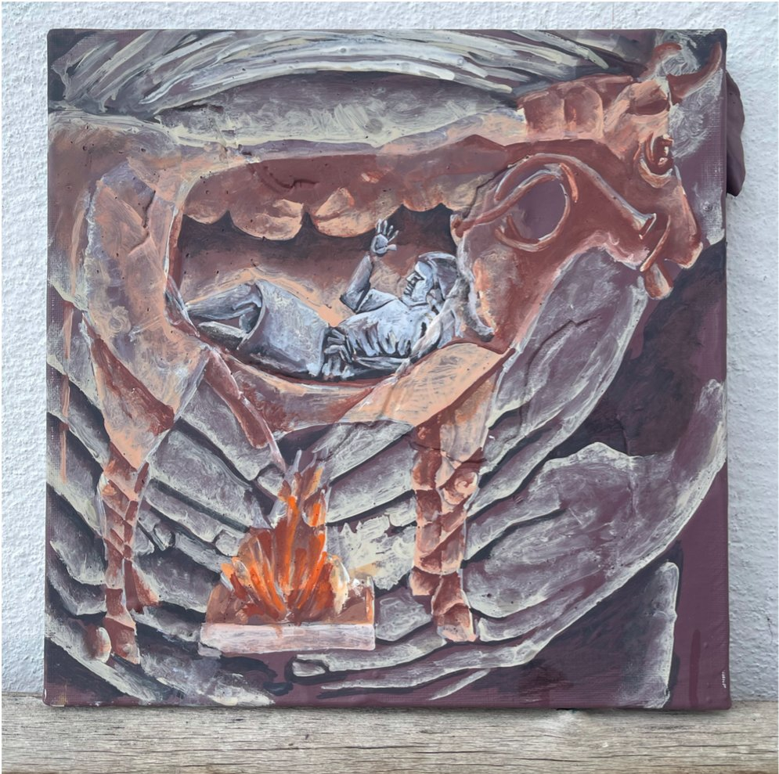

Adrian Schachter
Hephaestus' robots, 2021
Tempera, acrylic and modeling paste on wooden panel
30 x 30

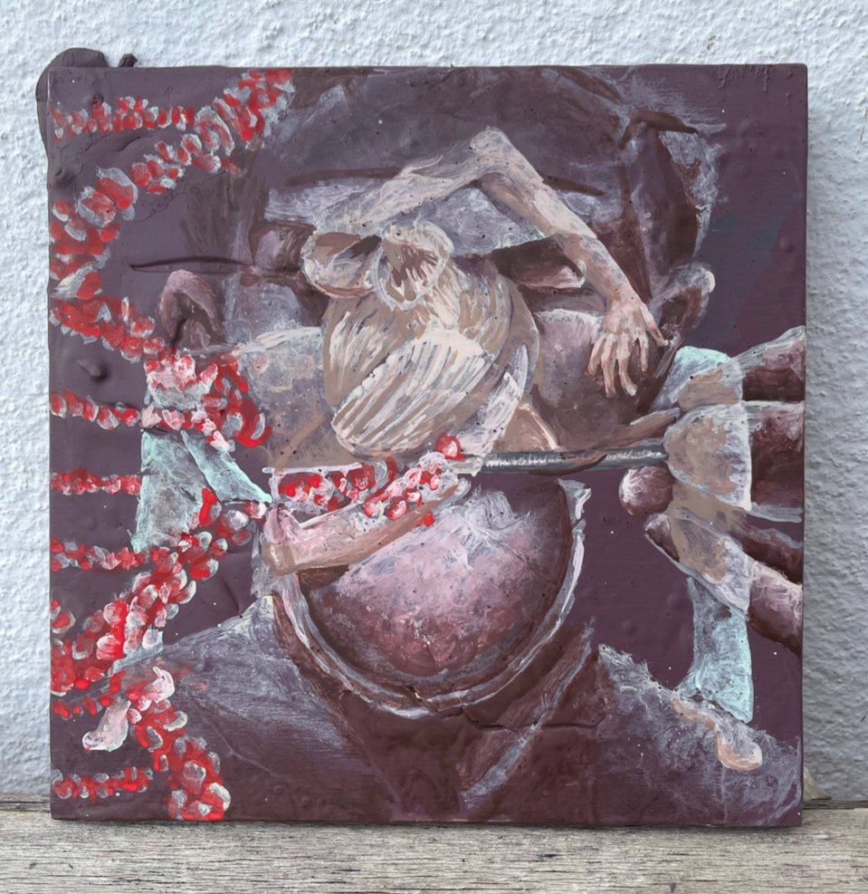

Adrian Schachter
People are awesome 2021, 2021
Tempera, acrylic and modeling paste on wooden panel
20 x 20

BALDASSARRE MARIO

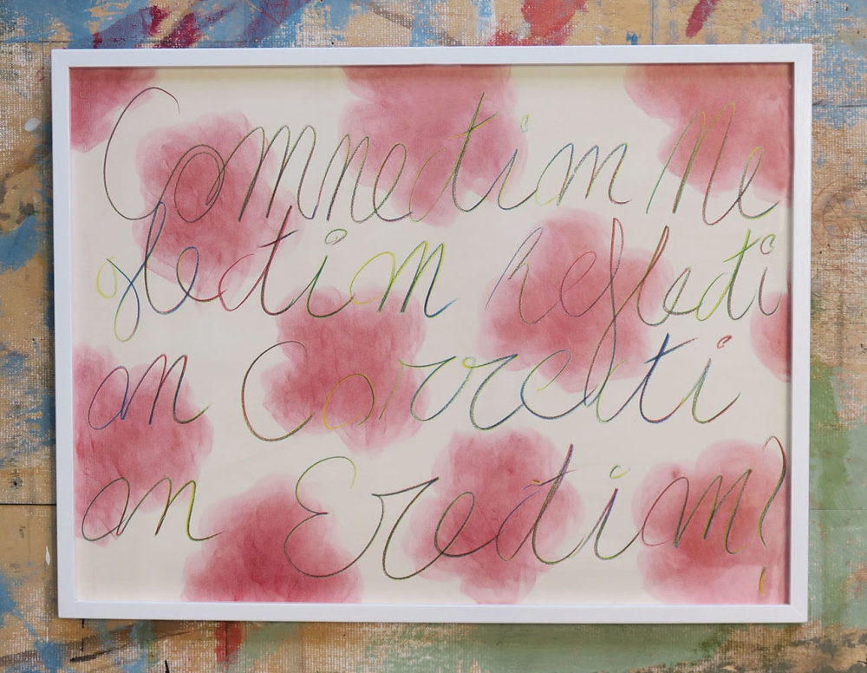

Baldassarre Mario
Untitled (Something Special), 2021
Pigment and pencil on 250gr paper
55 x 70

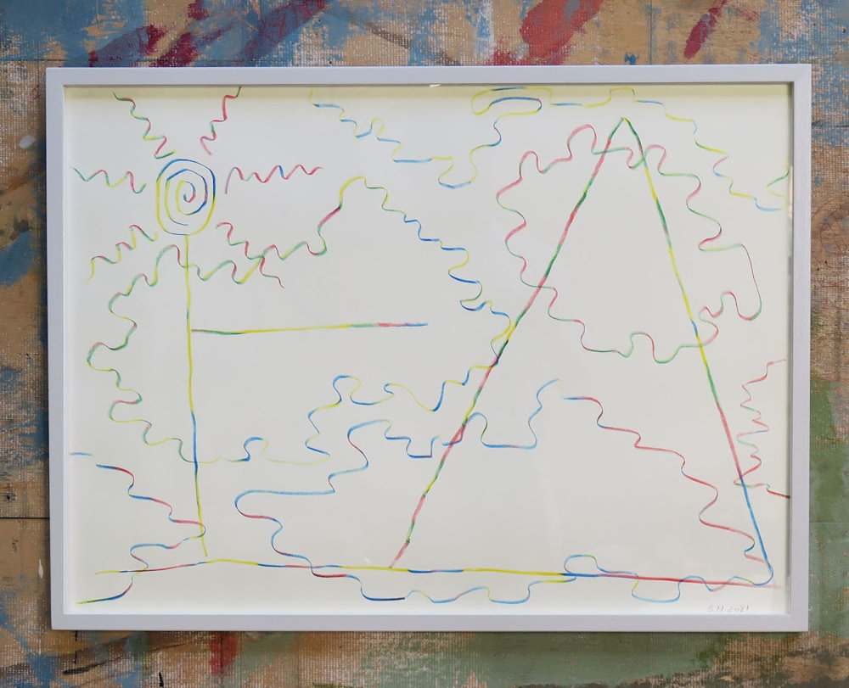

Baldassarre Mario
Untitled (Landscape), 2021
Pencil on 250gr paper
55 x 70

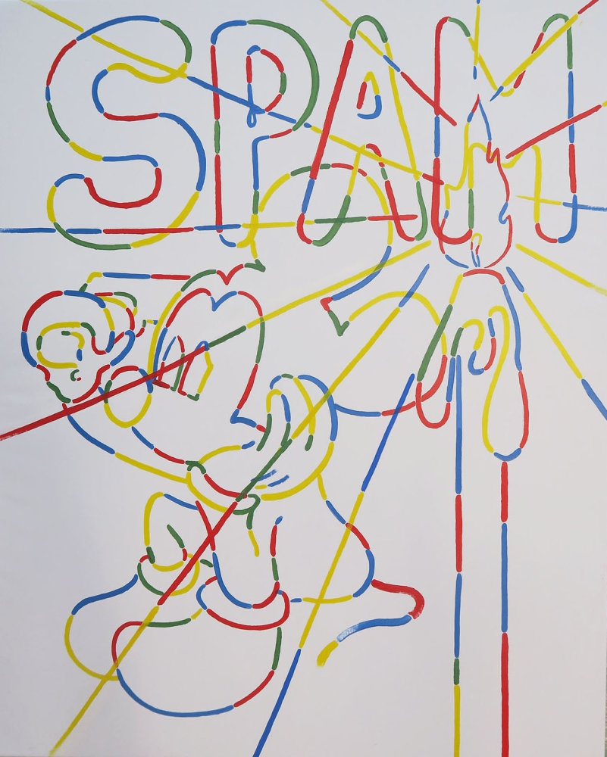

Baldassarre Mario
Untitled (My second Google painting), 2021
Oil on Canvas
80 x 100

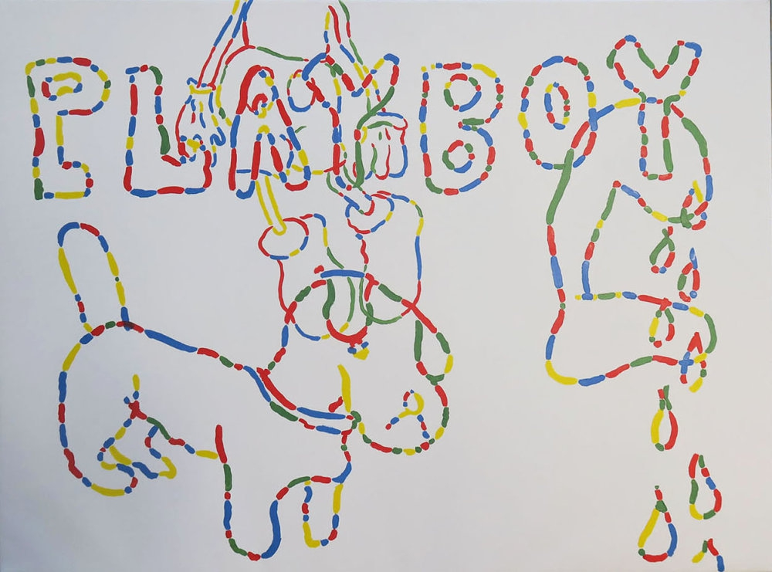

Baldassarre Mario
Untitled (My first Google painting), 2021
Oil on Canvas
75 x 100

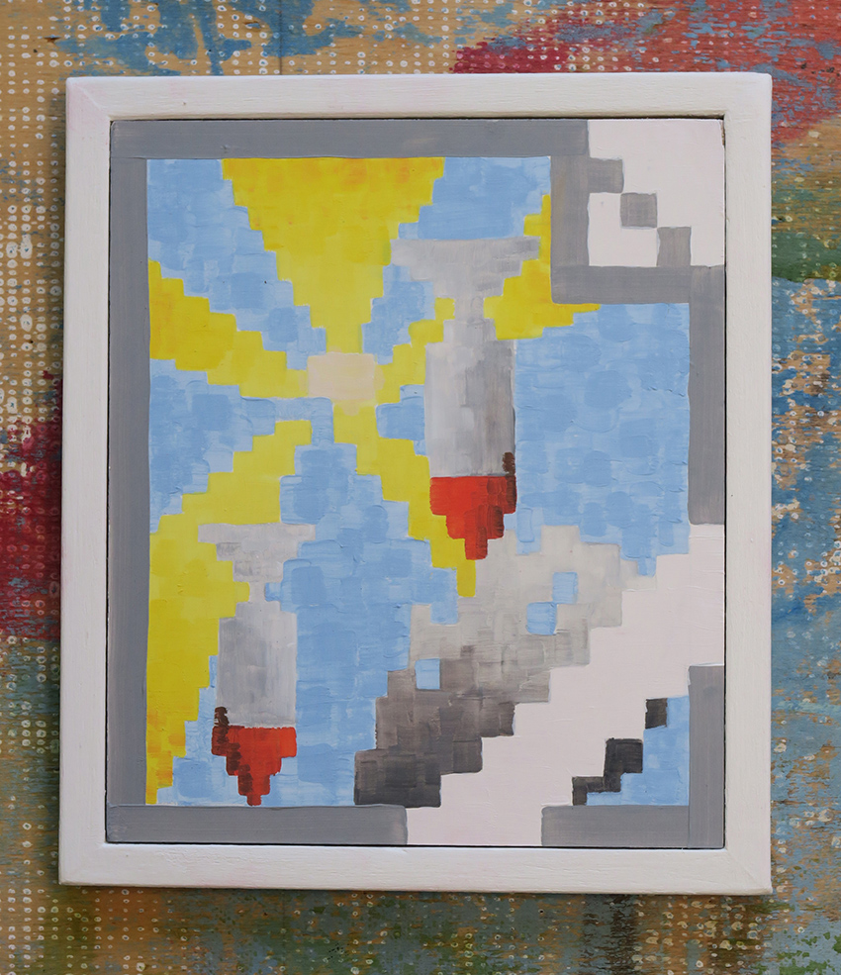

Baldassarre Mario
Image may contain (Rockets), 2021
Signed & dated
Oil on prepared board
17 x 15 cm

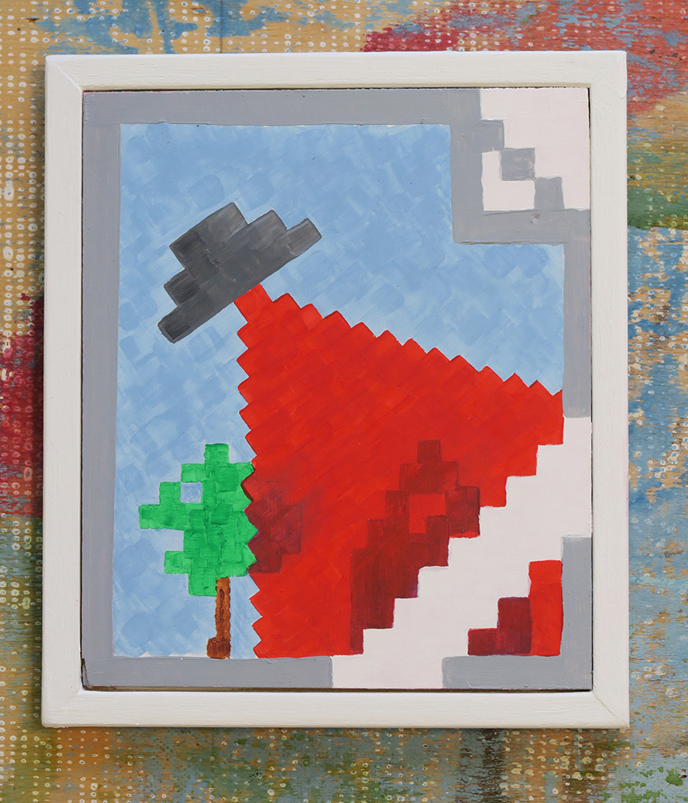

Baldassarre Mario
Image may contain (U.F.O.), 2021
Signed & dated
Oil on prepared board
17 x 15 cm

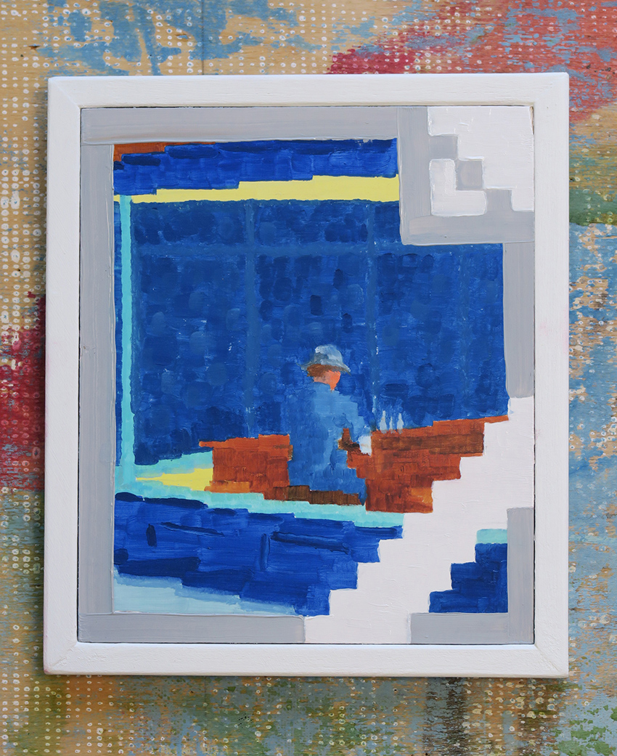

Baldassarre Mario
Image may contain (Nighthawk), 2021
Signed & dated
Oil on prepared board
17 x 15 cm

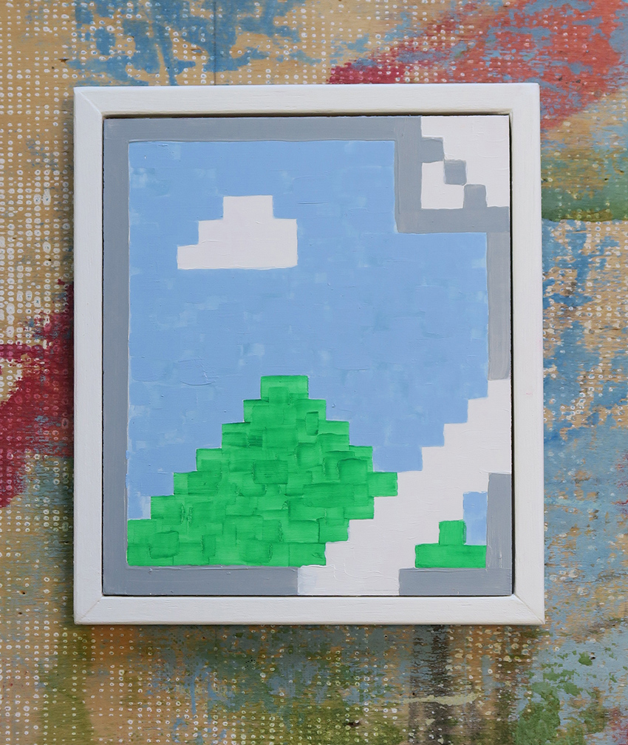

Baldassarre Mario
Image may contain, 2021
Signed & dated
Oil on prepared board
17 x 15 cm

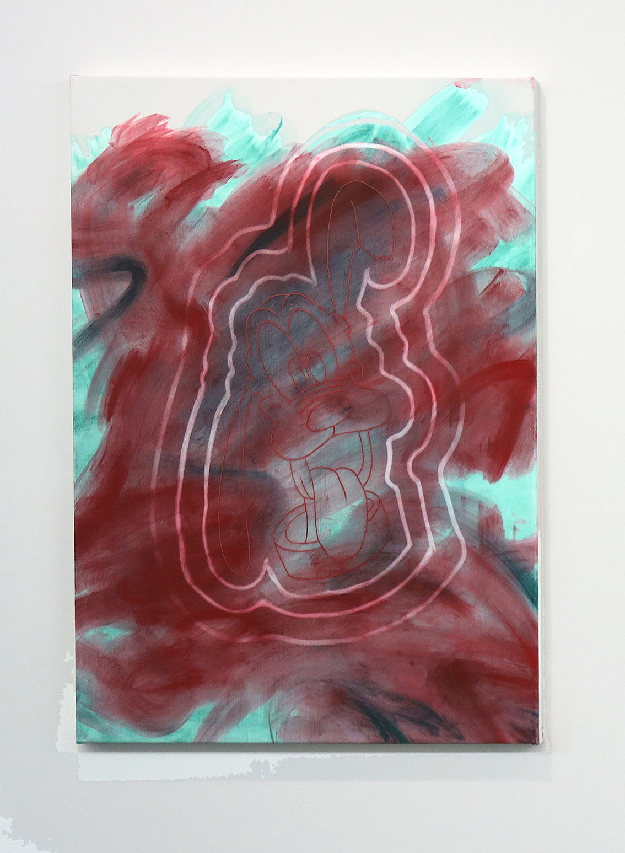

Baldassarre Mario
Glitch 1, 2021
Signed & dated
Pigment and mixed media on canvas
115 x 80 cm

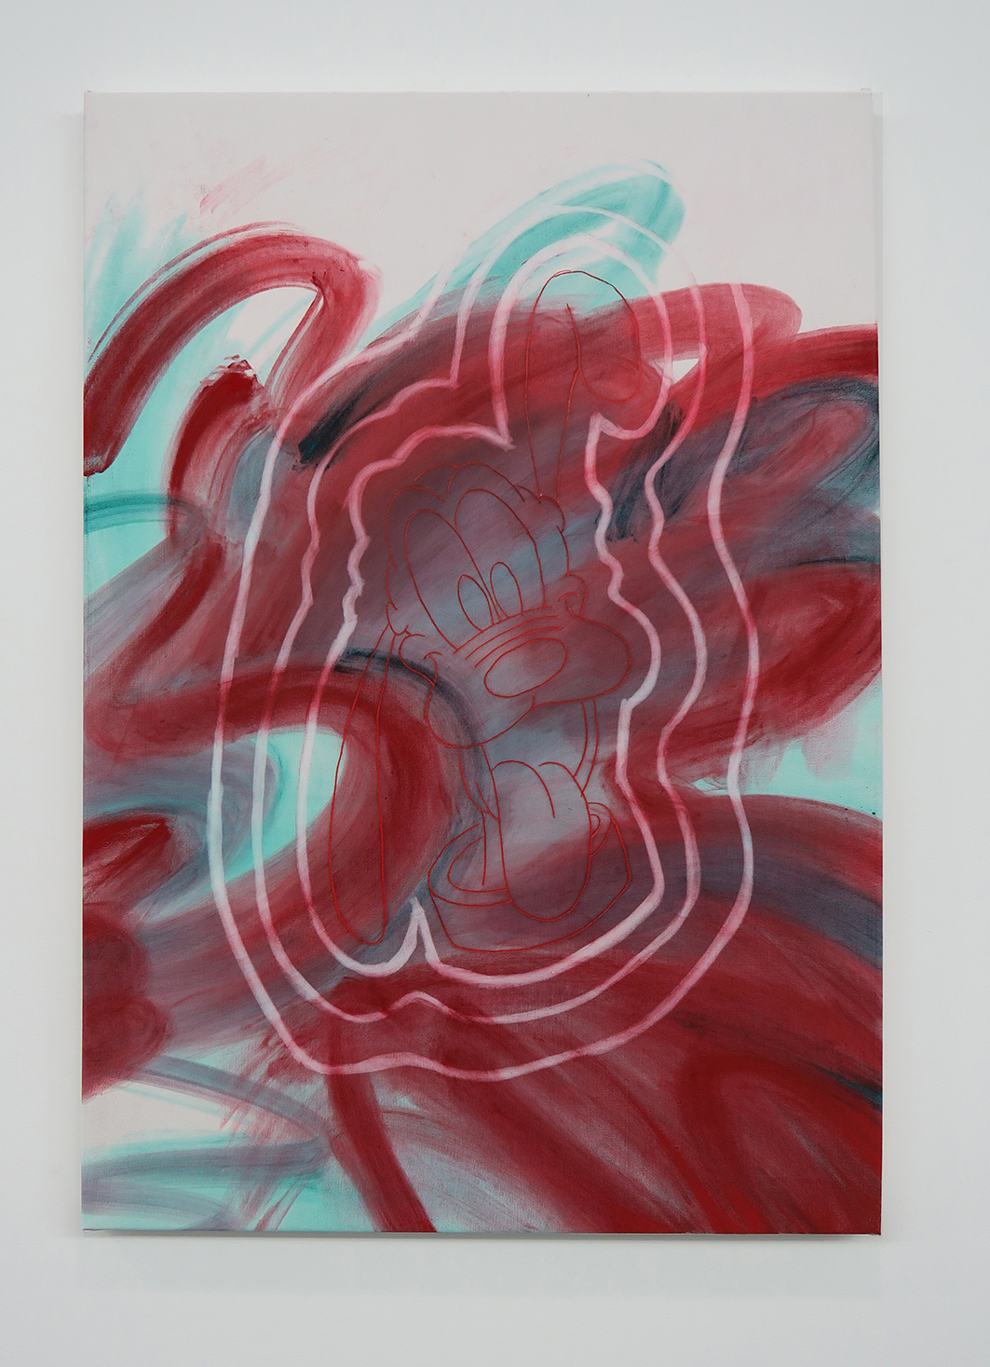

Baldassarre Mario
Glitch 2, 2021
Signed & dated
Pigment and mixed media on canvas
115 x 80 cm

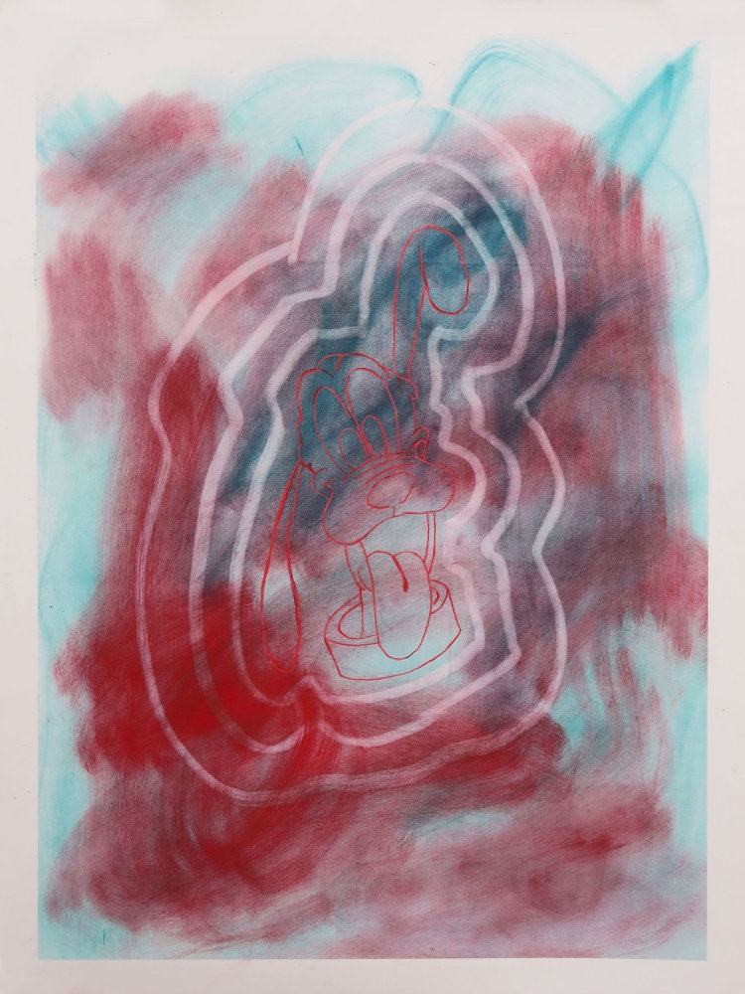

Baldassarre Mario
Untitled (Glitch), 2021
Pigment and pencil on 250gr paper
55 x 70

CURRICULUM VITAE

ADRIAN SCHACHTER (1996, New York, lives and works in Milan and the Engadin)
BFA Graduate Degree with High Honors School of Visual Arts, New York

Solo Exhibition
Adrian Schachter works on paper, online exhibition curated by Lauren Powell, https://laurenpowellart.com/worksonpaper/adrianschachterrich

Group Exhibitions / Residencies
2021
Inaugural exhibition at Spazio Amanita, Florence, IT, Curated by Caio Twombly and Christian Luiten.
The Third Decade, theStable, S’chanf, CH, curated by Fritz Steinhart
2020
Times Square residency at the Zabludowicz Collection La Totale Collective, 1st iteration, Les Moulins, FR, Curated by Leo Orta, Iseult Perrault and Simon Sixou.
2019
Superzoom, curated by Ferdinand Gros, Paris, FR.
Sicily Art Residency Exhibition, Linguaglossa, Sicily, IT.
Family Vacation, curated by Kenny Schachter, Los Angeles, CA.
2018
Superzoom, curated by Ferdinand Gros, Miami Beach, FL.
Nuclear Family, curated by Kenny Schachter, Shanghai, CN.
Family Guy, curated by Kenny Schachter and Simon Lee, Simon Lee Gallery, London UK.
Mutants, curated by Caio Twombly and Christian Luiten, 132 Perry, New York, NY.
2017
Sho-ho House, curated by Something To Hate On (Raff Law, Dan Mould and Max Clarke), SoHo Revue, London, UK.
Cherry Blossom Festival, Ludlow House, New York, NY.
Nuclear Family, curated by Kenny Schachter and Magnus Edensvard, Ibid Projects, Los Angeles, CA.
Slipped Disk, 432 East 9th, curated by Caio Twombly, Kai and Adrian Schachter, New York, NY.
2016
Finders Keepers, 263 Bowery, curated by Caio Twombly, New York, NY. Clear Eyes, Avenue C, New York, NY.
2015
Rubbish, curated by Ciao Twombly, New York, NY.
Post Contemporary and War, curated by Caio Twombly, New York, NY.

Curatorial Projects
2017 Slipped Disk, 432 East 9th, curated by Caio Twombly, Kai and Adrian Schachter, New York, NY.

Baldassarre Mario (1993, London, lives and works in Florence)
Goldsmiths University of London, Fine art and History of art, London, 2016 Accademia di belle arti, Firenze 2013
Workshop production assistant, Studio Alicja Kwade, Berlin, 2017- 2019 First studio assistant Studio Hugo Wilson, London, 2016-2017

Solo Exhibition
2018
Solo exhibition, J.u.n.e, Berlin, DE.

Group Exhibitions
2021
The Third Decade, theStable, S’chanf, CH, curated by Fritz Steinhart
2020
Hot Mess – Group Show, Price Charles, Berlin, DE, curated by Yolande Gouws.
The Artist and modern life- Group show, FOR_A, Berlin, DE, curated by Diana Hohenthal.
May Italian Art – group show (online), Galleria Alessandra Bonomo, Rome, IT, curated Giuliana Benassi.
2019
Her/Hers – Group show, Bethanien Headquartiers, Berlin, DE.
Studio Group show, Studio Alicja Kwade, Berlin, DE, curated by Alicja Kwade.
2018
In house Residency – Two Person Exhibition, Accaventiquattro, Prato, IT, curated by Filippo Bigagli Divided Molitor.
Part 2 – Group show, Galleria Alessandra Bonomo, Rome, IT, curated by Teodora de Robilant.
Part 1 – Group show, Galleria Alessandra Bonomo, Rome, IT, curated by Teodora de Robilant.
2017
Concontemporaneo – Group show, Spazio Moo, Prato, IT.
Eis am Stiel – Group show, Deutsche Bank Frankfurter Allee 21, Berlin, IT, curated by Marie Von Papen.
2016
I am not Tino Sehgal – Group show, Nahmad Projects, London, UK, Curated by Francesco Bonami.
Poetics of space – Group show, Charlotte street 69, London, UK, curated by Aaron Cho.
Fine Art and History of Art finbal degree show, Goldsmiths University of London, London, UK.
2015
Spaces Contexts Habitats – Group show, Palazzo iscari, Catania, ITcurated by Pietro Scammacca.
Field labour- Group show, Green Pavillion Mile end, London, UK.
The common ground project – Group show, Arco Madrid side program, Madrid, ES, curated by Marco Bene.

